**Online Learning Platform**

Submitted by

**Shivam Raikwal (240310120011)**

**Ravi Gupta (240310120010)**

**Vibhanshu Mitra (240310120015)**

For the award of the

**Post Graduate Diploma in Advanced Computing (PG-DAC)**

Under the supervision of

**Name:** Pankaj Mahto

**Designation:** Senior Project Engineer

**CENTRE FOR DEVELOPMENT OF ADVANCED COMPUTING**

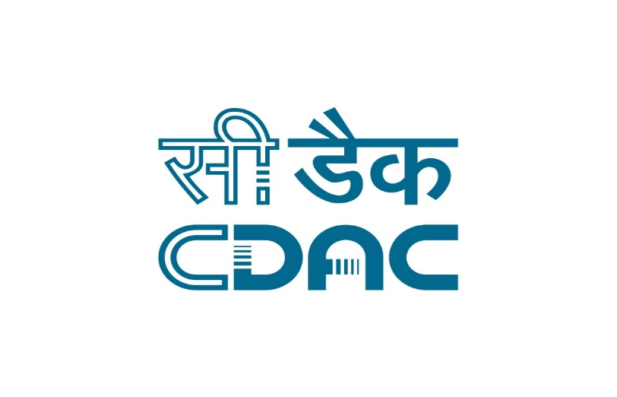

**Session: MAR-2024 To AUG-2024**

**INSTITUTIONAL AREA, JASOLA, NEW DELHI – 110025**

**DECLARATION**

We declare that this written submission represents our ideas in our own words and where other’s ideas or words have been included, we have adequately cited and referenced the original sources.

We also declare that we have adhered to all the principles of academic honesty and integrity and have not misrepresented or fabricated or falsified any idea/data/fact/source in our submission. We understand that any violation of the above will cause for disciplinary action by the Institute and so evoke penal action from the sources which have thus not been properly cited or from whom proper permission has not been taken when needed.

**Name**: Shivam Raikwal

**Signature:**

**PRN No.:** 240310120011

**Place:**

**Date:**

**Name:** Ravi Gupta

**Signature:**

**PRN No.:** 240310120010

**Place:**

**Date:**

**Name:** Vibhanshu Mitra

**Signature:**

**PRN No**.: 240310120015

**Place:**

**Date:**

**ACKNOWLEDGEMENT**

Presentation inspiration and motivation have always played a key role in the Success of any venture. We express our sincere thanks to Mr. Pankaj Mahto, center for Development of Advanced Computing(C-DAC), Delhi.

We pay deep sense of gratitude to Mr. Pankaj Mahto, Project Engineer, C-DAC, Delhi to encourage us to the highest peak and to provide us the opportunity to prepare the project. We are immensely obliged to our colleague for their elevating inspiration, encouraging guidance and kind supervision in the completion of our project.

We feel to acknowledge our indebtedness and deep sense of gratitude to our guide Mr. Pankaj Kumar Mahto whose valuable guidance and kind supervision given to us.

Name: Shivam Raikwal

Date:

Name: Ravi Gupta

Date:

Name: Vibhanshu Mitra

Date:

**Abstract**

The Online Learning System (OLS) is a robust software platform designed to facilitate and enhance educational experiences through digital means. This system integrates essential functionalities such as course creation, student enrollment, progress tracking, assessments, and reporting into a cohesive platform. The primary goal of OLS is to provide an accessible, flexible, and efficient learning environment for both educators and learners. By automating administrative tasks and centralizing educational resources, OLS reduces manual workload, minimizes errors, and supports better educational outcomes through real-time data and analytics. Ultimately, the system aims to deliver a seamless and enriching experience for users, promoting effective learning and teaching while ensuring educational excellence.

**Table of Contents**

Table of Contents

1. **Objective………………………………………………………………………………….7**
2. **Introduction…………………………………………………………………………….9**
   1. **Problem Domain………………………………………………………………..9**
   2. **Solution Domain………………………………………………………………..10**

**3 Methodlogy………………………………………………………………………… 10**

**3.1 Documentation: Methodology provides for large documentation**……..11

**3.2 Agile Development……………………………………………………………………………12**

**3.3 Agile………………………………………………………………………………………………..12**

**4 Requirement…………………………………………………………………………..13**

**4.1 User Case For User…………………………………………………………………………….14**

**4.2 User Case for Admin………………………………………………………………………….15**

1. **System Architecture………………………………………………………………..16**
   1. **E R Diagram …………………………………………………………………………………….17**
2. **Technology Used……………………………………………………………………….18**
3. **RESULT ANALYSIS……………………………………………………………………..20**

**8 Conclusion………………………………………………………………………………..26**

**9 Future Scope………………………………………………………………………………27**

**10 References………………………………………………………………………………….28**

**LIST OF FIGURES**

Figure 1 Use Case for User 14

Figure 2 Use Case for Admin 15

Figure 3 System Architecture 16

Figure 4 E R Diargram 17

Figure 5 User Registration 20

Figure 6 Login Page 21

Figure 7 Tutor Registration 22

Figure 8 Tutor Dashboard 23

Figure 9 Student Dashborad 24

Figure 10 Profile Page 25

1. **OBJECTIVE**

**The main objectives of the Online Learning System (OLS) are:**

1. Provide a Free and Accessible Learning Platform: Offer a centralized platform where users can access a wide range of study materials and courses for free, ensuring education is accessible to all.
2. Connect Tutors and Learners: Facilitate seamless interaction between tutors and learners, allowing for efficient course creation, management, and delivery.
3. Enhance Academic Success: Simplify the learning process by providing continuous support and comprehensive resources, which are crucial for both exam preparation and general education.
4. Automate Administrative Tasks: Streamline administrative workflows, such as student enrollment, course management, and progress tracking, to reduce manual workload and errors.
5. Ensure Secure and Efficient Data Management: Safeguard user data and ensure easy retrieval of information for tutors, learners, and administrators.
6. Improve User Experience: Design the platform to provide an intuitive and engaging learning experience, incorporating interactive tools such as quizzes, discussion forums, and multimedia content.
7. Reduce Educational Barriers: Minimize the stress and challenges associated with finding the right study materials by offering everything students need in one convenient location.
8. Provide Real-Time Analytics and Reporting: Enable administrators and tutors to access detailed reports and analytics to monitor progress, improve decision-making, and optimize course offerings.
9. Support Scalable Education Delivery: Ensure the platform can cater to a diverse range of educational needs, from individual courses to large-scale academic programs.
10. Centralize Educational Resources: Connect all educational tools and resources on a single platform to promote better coordination and resource sharing across different courses and programs.
11. Empower Tutors: Provide tutors with easy-to-use tools for course creation and management, allowing them to reach and teach a broader audience effectively.
12. Admin Control and Management: Give administrators full control over user management, content oversight, and system settings, ensuring a secure and organized learning environment.
13. **INTRODUCTION**

It is an online platform that connects tutors and learners,In today’s fast-paced educational environment, students often struggle to find the right study materials, especially during exams. This platform addresses these challenges by providing a centralized hub for all learning resources. By offering a wide range of study materials and courses, it ensures students have everything they need in one convenient location. This simplifies the learning process, reduces stress, and enhances academic success through continuous support and comprehensive resources, catering to both exam preparation and general education needs.

After the treatment is over the patient visits receptionist in the hospital and the billing is done according to the tests, doctor’s fees, prescribed medicines, hospital charges and taxes and a receipt will be printed.

* 1. **Problem Domain:**

In today’s educational landscape, students frequently encounter difficulties when preparing for exams due to the scattered and fragmented nature of available study materials. The process of locating the right resources often involves navigating through multiple websites or platforms, which can be time-consuming and inefficient. This disorganization leads to a significant amount of stress and anxiety, as students struggle to find and manage the content they need. The lack of a centralized and structured system further exacerbates these issues, making it challenging for students to maintain focus and effectively manage their study time. The result is a less effective learning experience, where valuable time is lost and academic performance can suffer.

* 1. **Solution Domain:**

The Online Learning System (OLS) offers a comprehensive solution to these challenges by providing a centralized platform where all study materials and educational resources are readily accessible in one place. By integrating a wide range of courses and study aids into a single, user-friendly interface, OLS simplifies the process of finding and using educational content. This centralization not only saves time but also reduces the stress associated with searching for materials, allowing students to focus more on their studies. The platform’s organized and structured approach ensures that students have everything they need for both exam preparation and ongoing learning, all in one convenient location. Additionally, OLS supports a continuous learning experience by providing resources that cater to various educational needs, ultimately enhancing the effectiveness of students' studies and improving their academic outcomes.

1. **METHODLOGY**

Software engineering is carried out using preferred procedure techniques to

progress the quality of a software development effort. A methodology is defined as a collection of procedures, techniques, tools, and documentation aids which will help

developers in their efforts (both product and process related activities) to implement a

new system. For successful implementation, a well-organized and systematic approach is crucial. Therefore, several methodologies were developed to encourage the systematic approach to planning, analysis, design, testing and implementation. Methodologies offer various tools and techniques to assist in analysis, design and testing in terms of detailed design of software, data flowcharts and database design.

**3.1 Documentation: Methodology provides support for large documentation.**

**Analysis and Design Support:** A well-defined structure of the methodology helps for analysis and designing to development process.

**Implementation:** The system should be implemented as per plan.

**Testing Support:** More testing, more reliable the product is.

**Object Oriented Approach:** Object oriented concepts will be used in developing the project as it supports component re-usability.

**3.2 Agile development**

Agile software development refers to software development methodologies centered round the idea of iterative development, where requirements and solutions evolve through collaboration between self-organizing cross-functional teams. The ultimate value in Agile development is that it enables teams to deliver value faster, with greater quality and predictability, and greater aptitude to respond to change. Scrum and Kan-ban are two of the most widely used Agile methodologies. Below are the most frequently asked questions around Agile and Scrum, answered by our experts.

**3.3 What is Agile?**

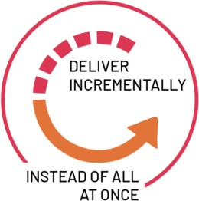

*Figure 0. Agile Diagram.*

Agile software development refers to a group of software development methodologies based on iterative development, where requirements and solutions evolve through collaboration between self-organizing cross-functional teams. Agile methods or Agile processes generally promote a disciplined project management process that encourages frequent inspection and adaptation, a leadership philosophy that encourages teamwork,

self-organization and accountability, a set of engineering best practices intended to allow for rapid delivery of high-quality software, and a business approach that aligns development with customer needs and company goals. Agile development refers to any development process that is aligned with the concepts of the Agile Manifesto. The Manifesto was developed by a group of fourteen leading figures in the software industry, and reflects their experience of what approaches do and do not work for software development. Read more about the Agile Manifesto. Did you know that Agile can also be applied to hardware projects? Learn about C prime's revolutionary Agile for Hardware framework.

# **REQUIREMENT**

Hardware Requirement

* Processor: i3 and above
* RAM: 256MB or more

Software Requirement

* Fast Ethernet
* LCD monitor
* Space-saving footprint
* Development End: Spring Boot, Spring MVC, Hibernate, MySQL •
* Designing End: HTML5, Materialized CSS, Themyleaf
* Tools : Eclipse IDE, MySQL Workbench 8.0 CE, Browser.

# 4.1 Use Case for User

# 

*Figure 1. Use Case for User*

* 1. Use Case for Admin

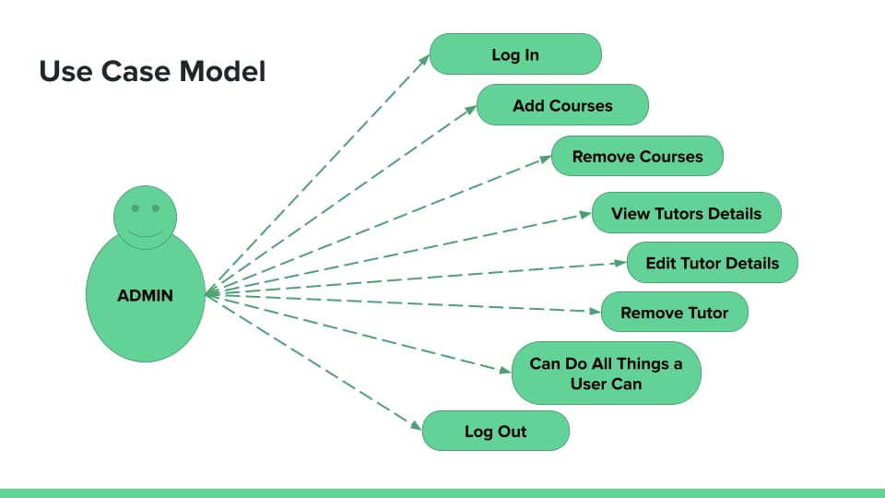

*Figure 2. Use Case for Admin*

**5. System Architecture**

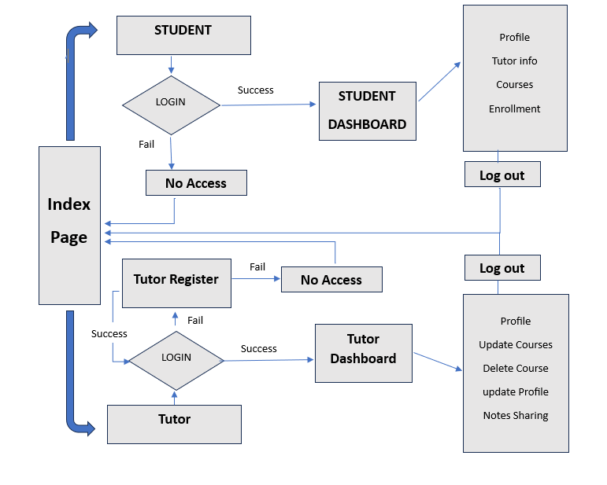

Figure 3. System Architecture

**5.1 E-R Diagram**

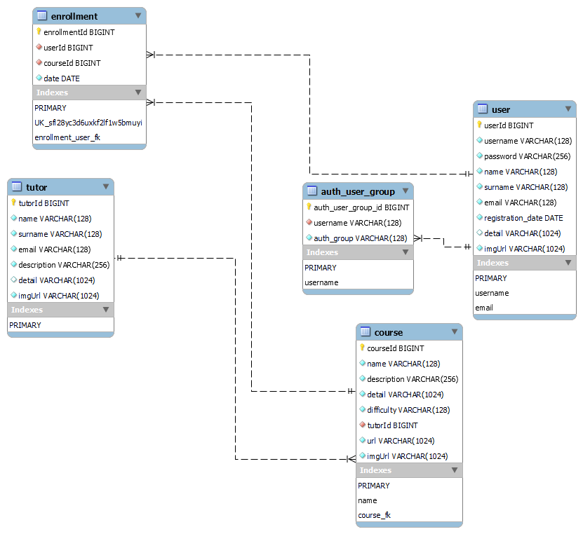

*Figure 4. ER Diagram*

**6. Technologies Used**

**Backend:**

* **Framework:**SpringBoot  
  Spring Boot is utilized to simplify the development of production-ready Spring applications. It provides a range of features to streamline configuration and deployment, including an embedded server and automatic configuration.
* **Language:**Java  
  Java is the primary language used for backend development, offering a robust and reliable environment for building scalable and high-performance applications.
* **WebFramework:**SpringMVC  
  Spring MVC is employed to handle web requests and responses, facilitating the development of web applications with a well-defined architecture and separation of concerns.
* **Data Access & Persistence:** Spring Data JPA, Hibernate ORM  
  Spring Data JPA and Hibernate ORM are used for managing data access and persistence. They simplify database interactions by providing object-relational mapping (ORM) capabilities and streamlining data operations.

**Frontend:**

* Templating: Thymeleaf, JavaScript  
  Thymeleaf is used as the server-side templating engine, enabling the dynamic generation of HTML pages based on server-side data. JavaScript enhances interactivity and functionality on the client side, allowing for dynamic updates and improved user experiences.
* CSS Framework: MaterializeCSS  
  MaterializeCSS is utilized as the CSS framework to provide a modern, responsive design based on Google's Material Design principles. It offers a set of pre-designed components and styles to ensure a consistent and visually appealing user interface.

**Database:**

* **System:** MySQL  
  MySQL is the relational database management system used to handle the storage and management of data. It is an open-source database known for its reliability, performance, and ease of use. MySQL supports Structured Query Language (SQL) for querying and managing data, making it a robust choice for handling complex queries and ensuring data integrity in the application.
  1. **RESULT ANALYSIS**

**UI Implementation**

User Registration

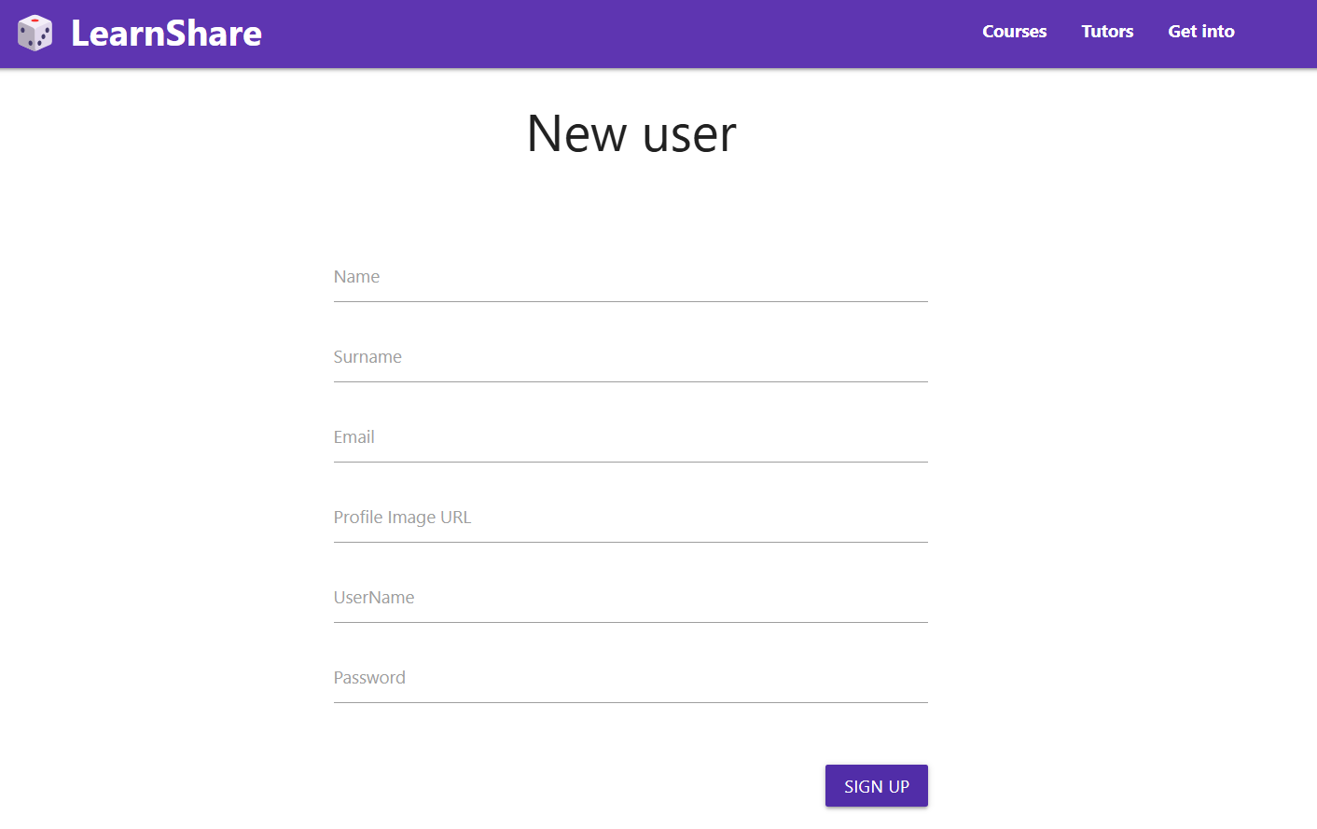

*Figure 5. Register page*

**UI Implementation**

Login Page

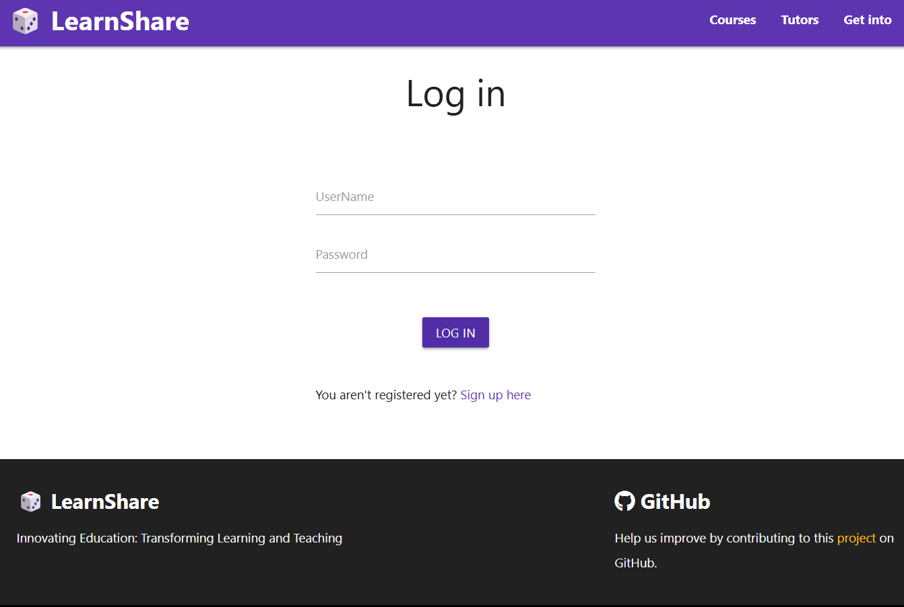

*Figure 6. Login page*

**UI Implementation**

Tutor Registration

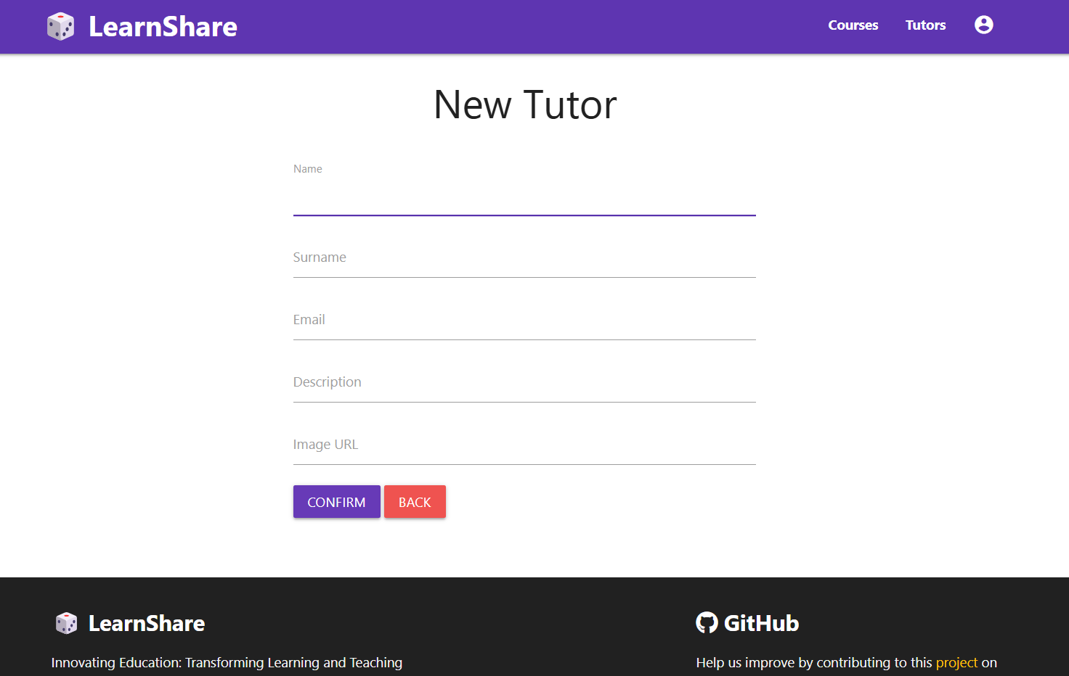

*Figure 7. Tutor Register page*

**UI Implementation**

Tutor Dashboard

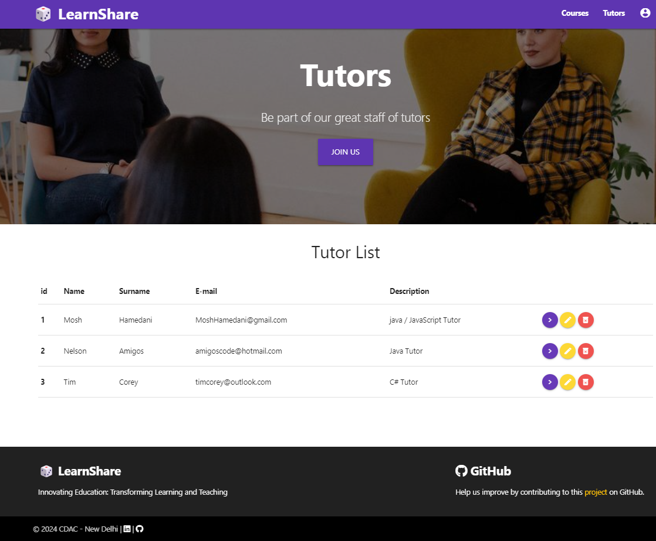

*Figure 8. Tutor Dashboard page*

**UI Implementation**

Student Dashboard

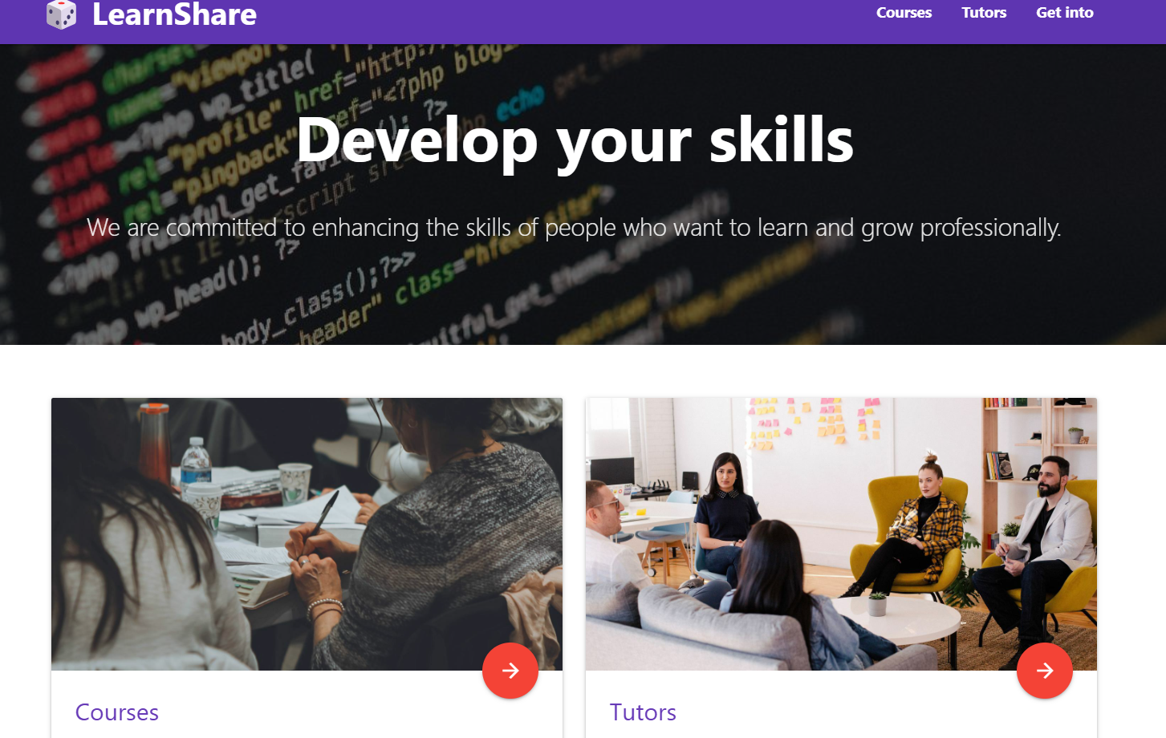

*Figure 9. Student Dashboard page*

**UI Implementation**

Profile page

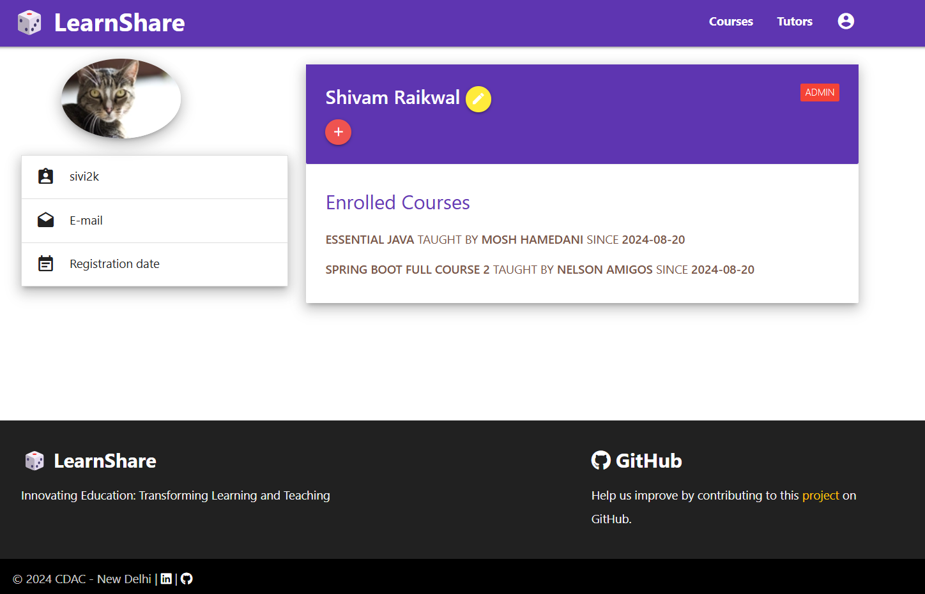

*Figure 10. Profile page*

# **CONCLUSION**

This platform not only simplifies exam preparation by consolidating all necessary resources into a single, easily accessible location but also fosters a continuous learning environment. Students frequently encounter difficulties during exams due to the challenge of locating relevant and timely study materials. This often results in increased stress and decreased efficiency, hindering their academic performance. Our platform effectively addresses these issues by offering a comprehensive solution that integrates a wide range of study materials and courses in one user-friendly interface.

By centralizing educational resources, the platform eliminates the need for students to navigate multiple websites or platforms, thereby saving valuable time and reducing stress. This streamlined approach allows students to focus more on their studies and less on the logistics of finding materials. Additionally, the platform supports both exam-specific preparation and broader educational goals, providing a well-rounded approach to learning. The result is an enhanced learning experience that not only improves academic performance but also promotes a more organized and efficient study process. Overall, by addressing common challenges and offering a cohesive solution, our platform significantly contributes to students' academic success and lifelong learning.

**9. Future Scope**

The future development of the Online Learning System (OLS) envisions several enhancements to further enrich the learning experience and expand the platform's reach:

* **Mock Exams Integration:** One significant enhancement will be the integration of mock exams, allowing users to take practice tests designed by tutors. These mock exams will be tailored to specific modules or topics, providing students with an opportunity to assess their knowledge and readiness before official exams. This feature will help learners identify areas for improvement and boost their confidence through regular practice.
* **Collaborative Learning Features:** To foster a more interactive and collaborative learning environment, the platform will introduce features such as discussion forums, group projects, and peer reviews. These tools will enable students to engage with each other, share insights, and collaborate on assignments, thereby enhancing their learning experience through peer-to-peer interaction and feedback.
* **Multilingual Course Offerings:** Expanding the platform to offer courses in multiple languages will broaden its accessibility and appeal to a global audience. By supporting various languages, the platform can cater to non-English speakers, open up new markets, and accommodate a diverse range of learners from different linguistic backgrounds.
* **Content Sharing by Tutors:** Future updates will include capabilities for tutors to share additional educational resources, such as notes, supplementary materials, and other content directly on the platform. This feature will provide students with more comprehensive learning materials and support, enhancing their overall educational experience.

These planned enhancements aim to provide a more dynamic, inclusive, and supportive learning environment, ensuring that the Online Learning System remains at the forefront of educational technology and meets the evolving needs of its users.

# **10. REFERENCES**

*Links:*

* <https://www.w3schools.com/css/>
* <https://docs.oracle.com/javase/8/docs/api/>
* <https://stackoverflow.com/>
* <https://javaee.github.io/javaee-spec/javadocs/>
* <https://developer.mozilla.org/en-US/docs/Web/JavaScript>
* <https://hibernate.org/orm/>
* <https://reactjs.org/>